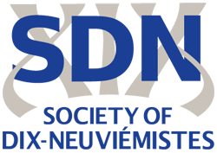

SEVENTEENTH ANNUAL SDN CONFERENCE

Call for Papers

DISCOVERY AND EXPLORATION

University of Southampton
8- 10 April 2019
We invite proposals for papers treating the conference theme in relation to French and Francophone culture, history, literature, music and art history in the long nineteenth century. Suggested topics include, but are not limited to:

Scientific explorations
Aesthetic and poetic experimentations
Empire and Postcolonial C19th
Unknown territories
Utopias and Dystopias
Science fiction
Great Exhibitions
Deep sea exploration
Experiments
Medicine and Literature
Scientific popularisation
Digital Humanities
Impact
Epistemocriticism
Gender and sexual explorations
Travel literature
Environmental Humanities
Self-discovery
Emotions and relationships
Napoleonic Expeditions
Accumulation and expansion
Multilingual encounters
Children’s literature
Ideologies of progress
Education
Methodologies

Proposals for individual papers or panels should be in the form of an abstract (c250 words) sent as an e-mail attachment in Word to sdn.proposals@yahoo.co.uk. Panels may take a traditional (20 minute paper) format, or be more experimental (eg discussion of pre-circulated papers, short presentations with discussant, round table). The deadline for proposals is 30 November 2018.

